LeadIQ Challenge

**Problem Statement:**

To build an Imgur image uploading service that exposes the REST API. The service should allow the client to upload images and to check the status of each image. The client should also be able to download the list of URLs of all the uploaded images.

**Implementation:**

**Language :** Node.js

**Tools :** Postman

**Github :** [**https://github.com/thedeveloperninja/nodejs_imgur_api.git**](https://github.com/thedeveloperninja/nodejs_imgur_api.git)

**Requirement 1: Submit image URLs for upload**

When the client submits the request with the list of URLs of the images, our service accepts the request and sends a unique job-id as the response. Using this job-id the client can monitor the status of the images submitted by him.

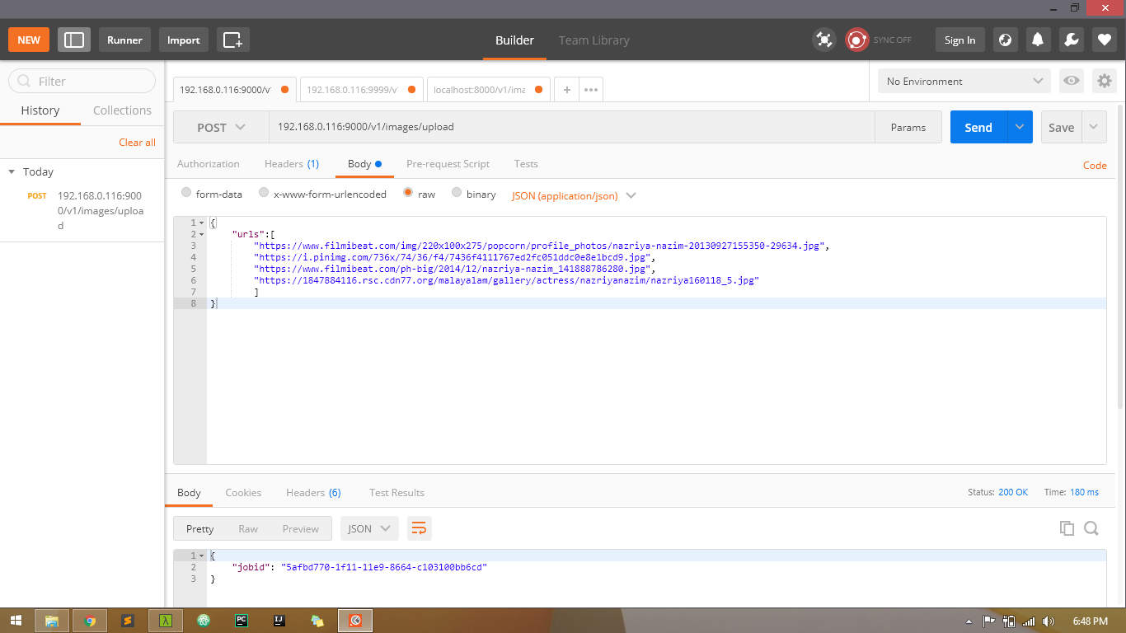

**Requirement 2: Get upload job status**

Using the job-id returned for submitting the URLs, the client can make a get request to the service with the unique job-id. For the given job-id our service will return the status of all the URLs submitted using the post method.

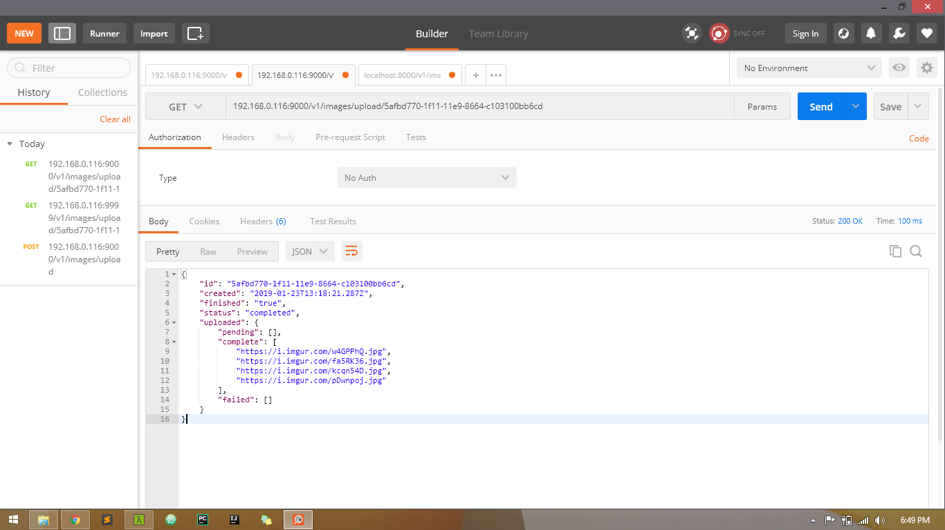

**Request** **:**

**GET /v1/images/upload/:jobId**

The request has no body and no query parameters**. :jobId** is an ID returned from the POST upload images API.

**Request body :**

None

**Requirement 3: Get list of all uploaded image links**

The client can send a simple get request to our service, our service will return the list of all the URLs of the images uploaded to imgur. Anyone with this link can access the images.

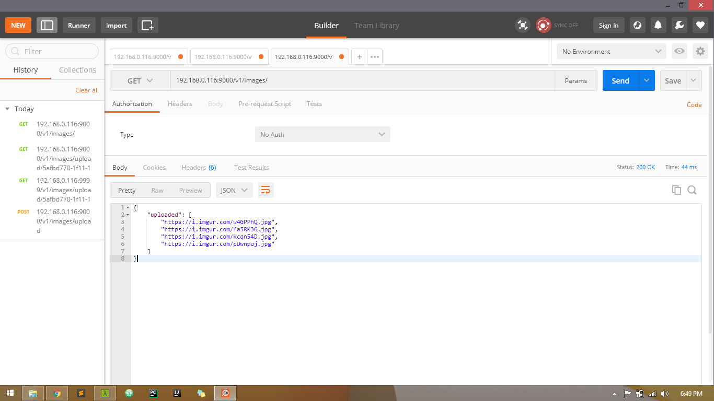

**Request** **:**

**GET /v1/images**

The request has no body and no query parameters.

**Request body :**

None